**[Anytown] Baptist Church**

**Purpose, Values & Vision Forum**

1. **ESTABLISHING PURPOSE**

based on resources from BA NSW & ACT, Church Health Team and The Johnmark Extension

[intentionally left blank]

**Foundational Concepts**

Three **Over-Arching Questions** for Churches to ask:

1. Do we have an ______________ picture of who we are?
2. Do we have a _____________ vision of where we are going?
3. Do we have a __________ understanding of the next steps necessary to take in this journey?

Three **Basic Assumptions**:

1. ______________ is desired by God & a natural outcome of healthy churches.
2. It is the _____________________ that causes churches to grow.
3. ________________ is foundational for any healthy church.

**Good Memories Exercise**

At what age did you give your life to Christ?

How long have you been attending this church?

Write down a few good memories that you have about your time at this church?

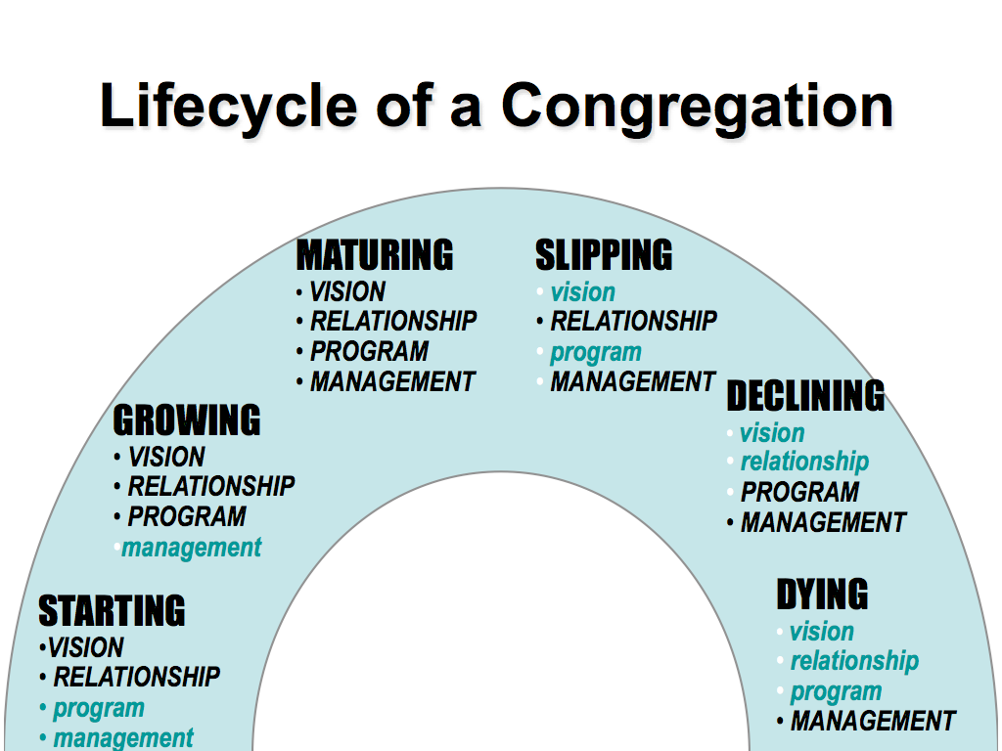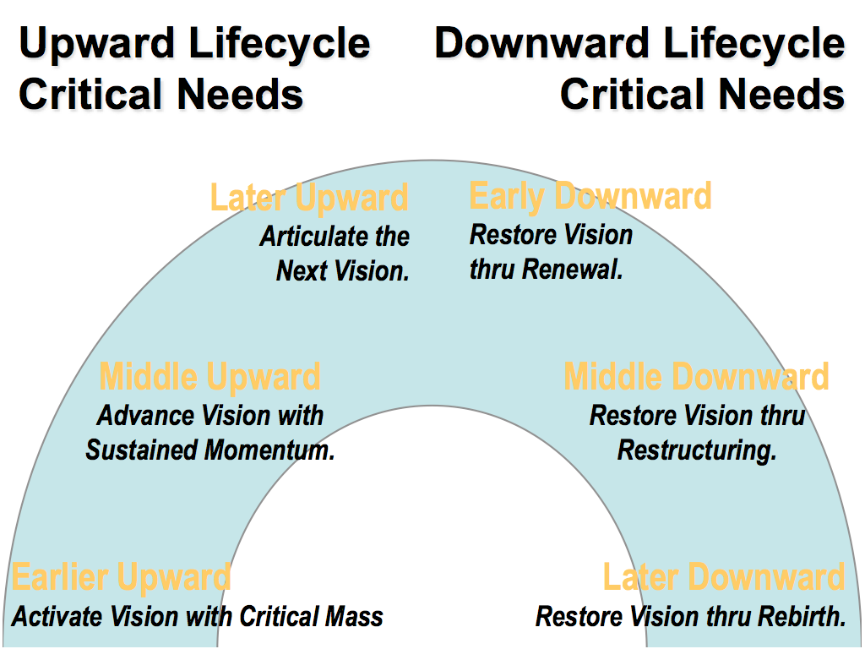

**The Importance of Purpose, Values and Vision**

**Purpose:** *Why we exist*

**Values:** *Drive the way we do things around here*

**Vision:** *Our future destination, a word picture of what we think the future might look like under God*

**Principles**

**Purpose:** *determined biblically*

**Values:** *uncovered not created*

**Vision:** *imparted by God, discovered through prayer, acknowledged by the church body*

**The Importance of Purpose, Values and Vision**

**Developing a Purpose Statement**

*Purpose is why we exist*

* Biblically Based
* Usually one sentence
* Over arching rather than specific
* Can be applied to most churches
* It will never go out of date

**Developing a Values Statement**

*Values describes the way we operate*

* Evident in the history / life of the church
* Values are uncovered not created
* Are recognised by a “gut reaction” (emotive response)
* Build quite slowly & change very slowly

**Developing a Vision Statement**

*Vision is our future destination – a word picture of what we think the future might look like under God*

* Vision is imparted by God, discovered through prayer, acknowledged by the church Body
* Vision is the specific picture of our future
* A Vision may have a life span of 2 to 5 years

**Developing a Strategic Plan**

*Strategic Goals: are the individual goals or steps we must take to reach our vision*

Each step should be SMART

* **S**pecific
* **M**easurable
* **A**chievable
* **R**elated to reaching the vision
* **T**imed

**Purpose Reflection**

Some Biblical References to Help Guide our Thinking…

Matthew 28:19-20

*‘”Therefore go and make disciples of all nations, baptizing them in the name of the Father and of the Son and of the Holy Spirit, and teaching them to obey everything I have commanded you. And surely I am with you always, to the very end of the age.”’*

Acts 1:8

*‘”… But you will receive power when the Holy Spirit comes on you; and you will be my witnesses in Jerusalem, and in all Judea and Samaria, and to the ends of the earth.”’*

Hebrews 13:15

*‘Through Jesus, therefore, let us continually offer to God a sacrifice of praise – the fruit of lips that confess his name. And do not forget to do good and to share with others, for with such sacrifices God is pleased.’*

Colossians 3:12-17

*‘Therefore, as God’s chosen people, holy and dearly loved, clothe yourselves with compassion, kindness, humility, gentleness and patience. Bear with each other and forgive whatever grievances you may have against one another. Forgive as the Lord forgave you. And over all these virtues put on love, which binds them all together in perfect unity.*

*Let the peace of Christ rule in your hearts, since as members of one body you were called to peace. And be thankful. Let the word of Christ dwell in you richly as you teach and admonish one another will all wisdom, and as you sing psalms, hymns and spiritual songs with gratitude in your hearts to God. And whatever you do, whether in word or deed, do it all in the name of the Lord Jesus, giving thanks to God the Father through him.’*

Romans 15:2, 4-7

*‘Each of us should please his neighbour for his good, to build him up… For everything that was written in the past was written to teach us, so that through endurance and the encouragement of the Scriptures we might have hope.*

*May the God who gives endurance and encouragement give you a spirit of unity among yourselves as you follow Christ Jesus, so that with one heart and mouth you may glorify the God and Father of our Lord Jesus Christ.*

*Accept one another, then, just as Christ accepted you, in order to bring praise to God.’*

1 Peter 2:9, 12

*‘But you are a chosen people, a royal priesthood, a holy nation, a people belonging to God, that you may declare the praises of him who called you out of darkness into his wonderful light…*

*Live such good lives among the pagans that, though they accuse you of doing wrong, they may see your good deeds and glorify God on the day he visits us.’*

Romans 12:5-6a

*‘… so in Christ we who are many form one body, and each member belongs to all the others. We have different gifts, according to the grace given us…’*

Ephesians 4:7,11-13

*‘But to each one of us grace has been given as Christ apportioned it…*

*It was he who gave some to be apostles, some to be prophets, some to be evangelists, and some to be pastors and teachers, to prepare God’s people for works of service, so that the body of Christ may be built up until we all reach unity in the faith and in the knowledge of the Son of God and become mature, attaining to the whole measure of the fullness of Christ.’*

Ephesians 3:10-11

*His intent was that now, through the church, the manifold wisdom of God should be made known to the rulers and authorities in the heavenly realms, according to his eternal purpose that he accomplished in Christ Jesus our Lord.*

There are, of course, many other relevant passages and ideas in the Bible. You may wish to note down any others that you think are particularly helpful for us as we seek God’s purpose for our church…

Example statements:

*Our purpose is to Know Christ and Make Him Known.*

*Our purpose is to Make and Grow passionate disciples / followers of Jesus.*

*To be a Christ-centred community growing in faith and presenting the Gospel to others.*

*Our purpose and passion is the mission of Christ.*

*Our purpose is meeting God, growing disciples and reaching out.*

List ideas about what should be included in our church purpose statement (this is not about how we ‘word’ it):

**Values Identification Exercise**

* choose 9 values from the list below that you think best describe this church
* ‘realised’ more than ‘aspirational’ values
* don’t need to be ranked in any order - just circle them
* add any values to the list you think might be missing before you start
* this exercise is meant to focus on church values not, individual values

A Biblically Based

B Generous

C Friendly

D Tolerant

E Traditional

F Risk Takers

G Warm & Hospitable

H Theologically Flexible

I A “safe” environment for wounded people

J Evangelistic

K Well organized

L Authentic “being real”, transparent, open

M Committed to high quality corporate Worship

N Involved in social justice

O Politically active & involved

P Family focused

Q Oriented to marginalized ministry

R Multi cultural

S Relevant to the needs of the community

T Prayer based

U A place of high participation by lay people

V Led by strong, capable leadership

W Strongly committed to supporting overseas mission

X

Y

Z

[intentionally left blank]

**Critical Issues**

What do you think are the major issues that this church will need to face over the next 2 years?

*

*

*

*

*

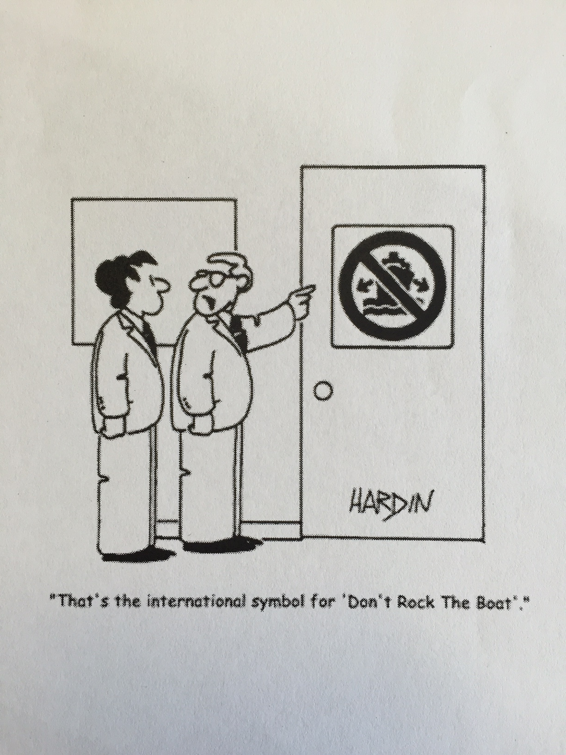

[intentionally left blank]

**Life Cycle of a Church**

*Mark where you think our church is on the life-cycle…*

[intentionally left blank]