**[Anytown] Baptist Church**

**Purpose, Values & Vision Forum**



1. **UNCOVERING VALUES**

based on resources from BA NSW & ACT, Church Health Team and The Johnmark Extension

[intentionally left blank]

**Foundational Concepts**

Three **Over-Arching Questions** for Churches to ask:

1. Do we have an **honest** picture of who we are?
2. Do we have a **shared** vision of where we are going?
3. Do we have a **clear** understanding of the next steps necessary to take in this journey?

Three **Basic Assumptions**:

1. **Growth** is desired by God & a natural outcome of healthy churches.
2. It is the **Holy Spirit** that causes churches to grow.
3. **Prayer** is foundational for any healthy church.

**The Importance of Purpose, Values and Vision**

**Purpose:** *Why we exist*

**Values:** *The way we operate, the way we do things around here.*

**Vision:** *Our future destination, a word picture of what we think the future might look like under God.*

**Life-cycle of a Congregation - reporting back**

**Critical Issues - reporting back**

**Summary of Issues Raised**

*For those interested, a full list of issues raised is available [note location].*



**CHRIST CENTRED**

1. enjoying a dynamic relationship with Jesus
2. relying on the Bible as foundational to shaping our understanding of Christ, our faith and the world
3. being led and empowered by the Spirit of Christ to live a life of worship
4. believing God is able to do more than we ask or imagine.

**MISSION SHAPED**

1. committed to the announcement and demonstration of the universal reign of God through Christ
2. motivated by love for God and others
3. seeing people, communities and societies transformed
4. biasing our resources toward mission, both locally and globally.

**RELATIONALLY COMMITTED**

1. serving each other and working together, honouring the varied expressions of our faith and practice and our cultural diversity
2. actively promoting healthy unity through mutual collaboration, transparency and accountability
3. prioritising authentic relationships over programs and structures
4. honouring marriage as an institution created by God as the foundation for a lifelong faithful union of a man and a woman.

**PEOPLE EMPOWERING**

1. nurturing a disciple making culture that encourages, shapes and releases every person to glorify God in all of their life
2. investing strategically in the identification, development and empowerment of leaders
3. respecting our heritage whilst championing further innovation.

**PARTNERSHIP ORIENTED**

1. recognising and celebrating God at work both within and beyond our movement
2. partnering with like-minded bodies in the mission of God both locally and globally
3. evidenced by mutual respect, healthy dialogue, and where appropriate resource sharing and the development of common goals.

**The Baptist ‘Core 5’ Values**

1. What are your initial impressions of these values as a whole?
2. How biblical do you think they are?

3. How closely do you think they reflect our values as a church community?

**Developing a Values Statement**

*Values describes the way we operate*

* Values are uncovered not created!
* Are in the DNA of a church
* Are recognised by a “gut reaction” (emotive response)
* Build quite slowly & change very slowly

There is value in identifying ‘core values’. They don’t have to try to express everything that’s important about being a healthy church. Our aim is to prioritise **3 core values** that define who we are as a church - what is distinctive about us.

A core value is something you’re willing to be punished for:

* even if some people will decide they don’t want to join your church
* to violate a core value is like selling your soul - you can’t do it

Can test by asking ‘what is an example that would affirm / violate this value?’.

**‘Real’ vs ‘Aspirational’ values:** once we’ve ‘uncovered’ real and demonstrable values, we will also consider whether there are any **‘missing’ values**, i.e. values that don’t show themselves in our life together, but that we’re deeply convicted should show themselves.

**Values revealed in ‘good memories’ stories:**

**Top 9 Values for our Church**

**Values Banner**

|  |  |  |
| --- | --- | --- |
|  |  |  |

**Missing Values:** *(optional, maximum of 2)*

* 1. 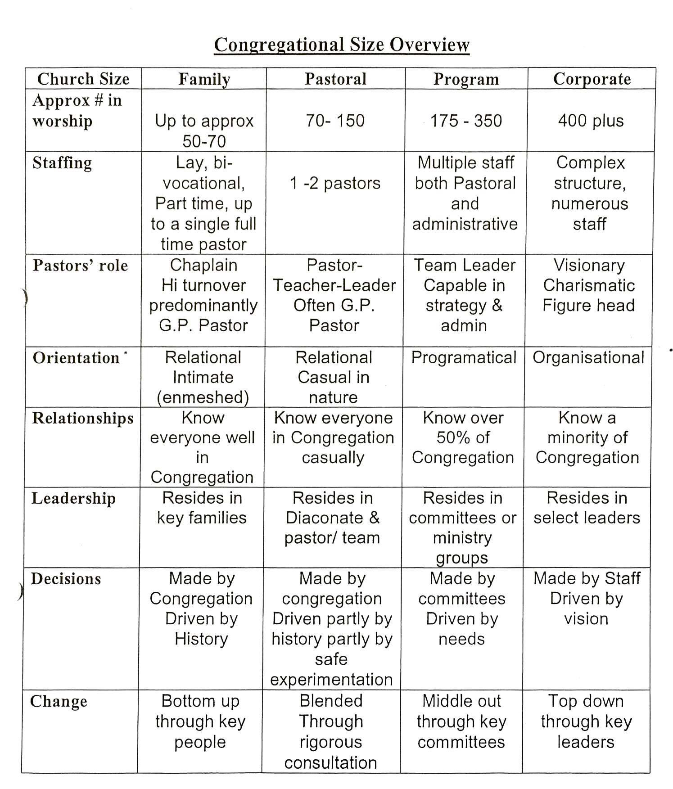 2.

**Congregational Sizes**

Churches do not transition easily or naturally, from one size to another. Different church sizes impact the way church life happens. There is no right or wrong size for a church but it is important for churches to act in keeping with the size they are, or the size they want to be.

*Tick the boxes that describe how the church presently operates (no need to collect):*

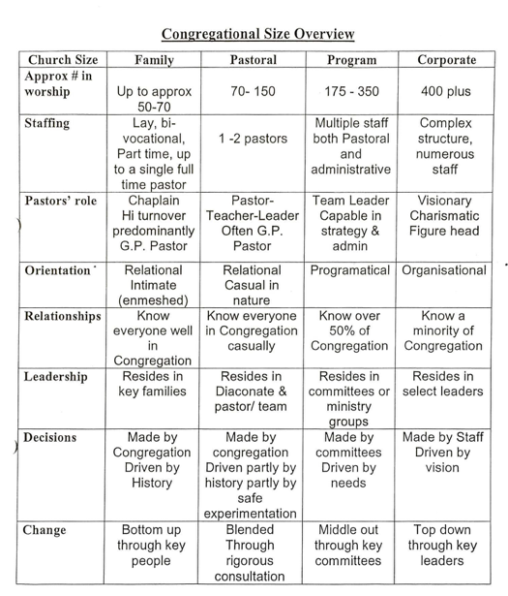

**Blended Ecology**

**Vision Exercise**

*Imagine that suddenly 5 years have passed…*

**What are you like personally?**

* Age
* Work
* Health
* New hobbies
* What ministry in the church are you involved in

**List aspects of what you think this church will look like in 5 years time:**

*

*

*

*

Size Smaller or larger

Feeling Excited or Fearful

Location Here or Elsewhere

Your Involvement More or Less

Average Age Older or Younger

**Take a few minutes to write down some things that you would love or dream this church could look like in 5 years time…**

[intentionally left blank]

**Negative Values**

Along with the positive, churches also usually have some negative values. Whilst we often don’t talk about the negative values they are still very powerful in the life of any church.

What are some values, attitudes, or behaviours that might hold us back at present?

*

*

*

[intentionally left blank]

**Draft Purpose Statement - Feedback**

*Purpose is why we exist*

* Biblically Based
* Usually one sentence
* Over arching rather than specific
* Can be applied to most churches
* It will never go out of date

**Consider the following draft purpose statement…**

**OUR PURPOSE:** [put draft purpose here]

This statement seeks to respond to the feed-back we received in the following ways:

One thing I like about this statement is:

I think this statement could be improved by:

Please complete, tear-off & deposit in the box labelled **Refining our Purpose**

in the church foyer by **[date]** at the latest.

[intentionally left blank]