**Anytown Church Visioning Forum 3: *Date***

Total Number of Participants:

**What Does God Want Our Future to Look Like?**

*Size or sending?*

*What kind of church?*

Simple church:

Neighbourhood church:

Regional church:

Resource church:

*In the next 3 years…*

|  |  |  |  |  |
| --- | --- | --- | --- | --- |
| **Size** | Same (smaller?)  **0** | 50% larger  **0** | 100% larger  **0** | Greater than 100% larger  **0** |
| **Facilities** | Much the same as present **0** | Minor alterations  **0** | Major alterations  **0** | Completely new  **0** |
| **Pastoral Staff** | No Pastor  **0** | Part time Pastor  **0** | Full time Pastor  **0** | Pastoral Team  **0** |
| **Church Leadership** | Same as present  **0** | Same system with some new faces  **0** | Slightly modified system with many new faces **0** | Completely restructured  **0** |
| **Largest Age Grouping** | An even spread across the ages  **0** | Largest group between 0-20  **0** | Largest group between 20-40  **0** | Largest group over 40  **0** |
| **Worship Style** | Same as present  **0** | Slight style change  **0** | Major style change  **0** | Multiple service style options **0** |
| **Orientation** | Completely outward focused  **0** | Weighted towards non Christians  **0** | Weighted towards Christians  **0** | Completely inward focused  **0** |
| **Ethnicity** | Mono-cultural  **0** | Numerous ethnic congregations under church oversight  **0** | Other nationalities present and serving as volunteers  **0** | Multi-cultural shown in leadership, style  **0** |

**The Bell Curve of Change**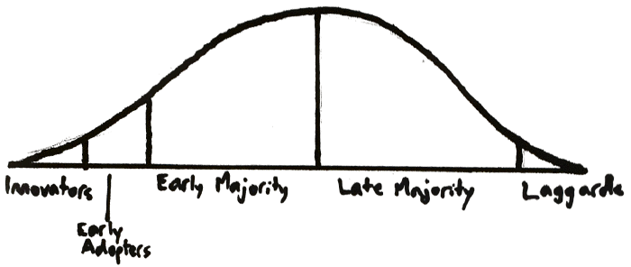

Innovators:

Early Adopters:

Early Majority:

Late Majority:

Laggards:

**Dreaming Together…**