**[Anytown] Baptist Church**

**Purpose, Values & Vision Forum**

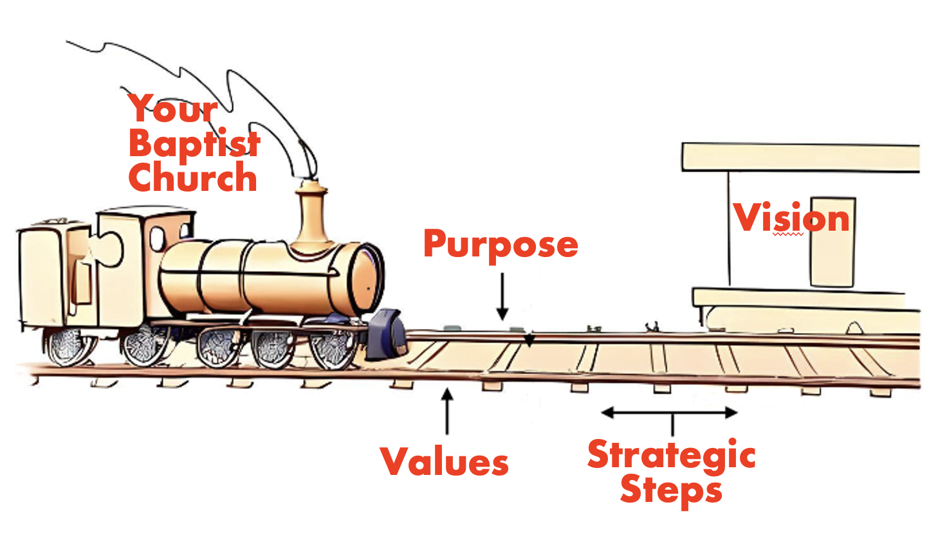

1. **SURFACING VISION**

based on resources from BA NSW & ACT, Church Health Team and The Johnmark Extension

[intentionally left blank]

**Foundational Concepts**

Three **Over-Arching Questions** for Churches to ask:

1. Do we have an **honest** picture of who we are?
2. Do we have a **shared** vision of where we are going?
3. Do we have a **clear** understanding of the next steps necessary to take in this journey?

Three **Basic Assumptions**:

1. **Growth** is desired by God & a natural outcome of healthy churches.
2. It is the **Holy Spirit** that causes churches to grow.
3. **Prayer** is foundational for any healthy church.

**The Importance of Purpose, Values and Vision**

**Purpose:** *Why we exist*

**Values:** *The way we operate, the way we do things around here.*

**Vision:** *Our future destination, a word picture of what we think the future might look like under God.*

Vision is imparted by God, discovered through prayer, and acknowledged by the church body.

**Purpose Statement - Final Draft**

This statement received strong support in the feedback when presented at the last meeting, and will therefore go into the final proposal when it is time to formally affirm our statements.

**OUR PURPOSE: [put your purpose statement here]**

*Remember - Purpose is why we exist*

* Biblically Based
* Usually one sentence
* Over arching rather than specific
* Can be applied to most churches
* It will never go out of date

Responding to earlier feedback this statement:

* [list reasons for choosing this statement here]

**What Does God Want Our Future to Look Like?**

*What do we believe is God’s desire for certain aspects of our church in the next 3 years?*

***Is God calling us to grow in size or by sending (church planting)?***

***What kind of church?****

|  |  |  |  |  |  |
| --- | --- | --- | --- | --- | --- |
| **Size** | Same (smaller?) | 50% larger | 100% larger | >100% larger |  |
| **Facilities** | Much the same | Minor alterations | Major alterations | Completely new |  |
| **Pastoral Staff** | No pastor | Part-time pastor | Full-time pastor | Pastoral Team |  |
| **Church Leadership** | Same as present | Same system with some new faces | Slightly modified system with many new faces | Completely restructured |  |
| **Largest Age Grouping** | An even spread across the ages | Largest group between 1-20 years old | Largest group between 21-40 years old | Largest group over 40 years old |  |
| **Worship Style** | Same as present | Slight style change | Major style change | Multiple service style options |  |
| **Orientation** | Completely outward focused | Weighted towards non-Christians | Weighted towards Christians | Completely inward focused |  |
| **Ethnicity** | Mono-cultural | Numerous ethnic congregations under church oversight | Other nationalities present and serving as volunteers | Multi-cultural shown in diversity, leadership, style |  |
|  |  |  |  |  |  |

**9 reasons people resist change - John Maxwell**

**1 Misunderstanding.**  When people do not understand why they should change, they will work to oppose it.

**2 Lack of ownership.** Church members who are not involved in the change process, they resist any new thing being pushed on them.

**3 Habit patterns.**  Routine makes people comfortable.  Since many people are habit prone anything that threatens their habits, they resist.

**4 Change is not worth the price.** Change is often costly. People often want to get something in exchange for their sacrifice.  The reward for changing may appear too small in comparison.

**5 Losing security, money or control.** People resist change when they are threatened with he loss of something that is valuable to them.

**6 Satisfaction factor.** People are *simply* satisfied with the old ways and don’t want to change.

**7 Negative attitude toward change in general.** Some people’s thought process is  based on the idea that NOTHING should be changed.

**8 Lack of respect for leader.** Unless followers trust the leaders, they will feel uncomfortable with change and will fight against it.

**9 Tradition**. People’s attitude is, “We’ve never done it that way before.”

Ref: Maxwell, John C. (1993). Developing the Leader Within You. Nashville, TN: Thomas Nelson.

**The Bell Curve of Change**

https://en.wikipedia.org/wiki/Technology_adoption_life_cycle

2.5% _____________________

13.5% _____________________

34% _____________________

34% _____________________

16% _____________________

Mark where you fit on the bell curve in

respect to dealing with change.

**A Churches Five Fold Ministry**

**Worship**

Public gathering, teaching, prayer, response, corporate giving, sacraments (Baptism, Communion)

**Discipleship**

Personal development of faith journey, ministering to others as well as receiving from others, growth in Christian character, counter cultural nature to life

**Fellowship**

In worship together, social gatherings, eating and drinking together, small groups, personal and social support for each other, intergenerational gathering

**Ministry**

Serving others in the church family, serving others not associated with this congregation, mission activities, short term mission trips, community involvement

**Evangelism**

Opportunities for people to make a clear faith decision for Jesus Christ, the realignment of worldview, proclamation of the gospel, training in personal evangelism

**Dreaming Together**

* This is about what you dream, not what you expect.
* This is about what the church might look like, not what we should do. This isn’t about strategies - strategies flow from this.
* This is about a future that you want to be a part of, not one that you’re expecting others to do for us. You would want to invest yourself into making it happen.
* This is about seeking to listen to God and each other, not personal agendas and desires.

*Write down some dreams you have for our church in the future…*



**Shared Dreams**

*Write down the shared dreams listed on the screen for our church in the future…*



Pray over these in coming days and feed-back to the visioning team, especially over the next week (**by next Sunday [date]**) anything further you want to share about what God is saying to us about these dreams and the future he is calling us to embrace.

You can email [name] with any feedback: [contact details]

Or you can speak to any of us directly. We are [names]

**Draft Values Statement - Feedback**

*Values describes the way we operate*

* Values are uncovered not created!
* Are in the DNA of a church
* Are recognised by a “gut reaction” (emotive response)
* Build quite slowly and change very slowly

**Consider the draft values statement on the back of this page…**

This statement seeks to respond to the feed-back we received in the following ways:



1 or 2 things I like about this statement is:

I think this statement could be improved by:

Please complete, tear-off & deposit in the box labelled **Refining our Values**

**Values Statement - Draft**

We affirm the ‘core 5’ values of the Baptist Churches of NSW & ACT:

Christ-centred, Mission-shaped, Relationally-committed, People-empowering, Partnership-oriented (see http://thecorefive.nswactbaptists.org.au/Core_Five/The_Core_Five.html for all that these entail).

We celebrate the following 3 values that are especially important to us and that help people know who we are as a church: **[values]**.

[VALUE]

We are committed to …

*[explanation…]*

[VALUE]

We are committed to …

*[explanation…]*

[VALUE]

We are committed to …

*[explanation…]*