**How To Make Vision A Reality**

Vision is definitely a key aspect to growing vital churches!

But having a vision is different from making it happen.

A powerful vision paints a picture of God’s preferred future, not what things are like in the present. That means that **a church has to change in order to see the vision become a reality**. Nearly every institution on the planet is change resistant! It is the very nature of things.

Churches need to develop a **“Strategic Plan”** on how they are going to get from where they are now to where God is calling them to be in the future.

A strategic plan is simply a list of Goals and the order in which the church is going to seek to reach those goals. When setting goals churches need to make sure they are **S.M.A.R.T** Goals.

**S.M.A.R.T** Stands for:

**S**pecific

**M**easurable

**A**chievable

**R**elated to the Task (Vision)

**T**imed

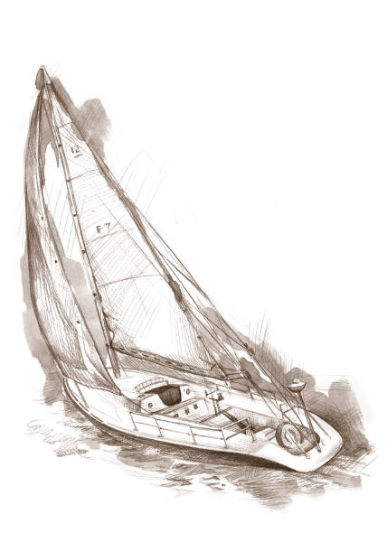***The Pessimist complains about the wind***

***The optimist expects the wind to change.***

***Good leadership adjusts the sails!***

When a boat tries to sail to a certain point, it is unable to do that in a straight line if the wind is blowing against it. The method it uses is to ‘tack’ from one point to another, zig zagging its way forward.

So too churches often need to make a series of small alterations in order to achieve the vision God has for their future. This can mean short term specific pastoral calls, sometimes stopping some ministries for a time in order to focus energy, sometimes re-diverting funds from one worthy project, in order to establish strategic changes that will enable the church to obey God by attaining the Vision He has placed before the church.

Sometimes churches need outside assistance to develop such strategic plans. Help may come from various sources; Association staff, A Regional Minister, Pastors or leaders of other churches with experience in this area. It’s always ok and sometimes more impacting to have external assistance in setting a strategic plan.

***Vision without strategy is no threat to Satan at all!***