**An Introduction to Purpose, Values and Vision**

(Published by the Baptist Churches of NSW & ACT Church Health Team, February 2025)

**“Aim at Nothing and You’ll Hit it Every Time”**

– Zig Ziglar

The desire for a fresh Vision may be driven by a variety of events and realities in church life:

* end of a long ministry
* pastoral transitions
* decline
* changes in community demographics
* conflict
* new building
* amalgamation
* end of one strategic plan

Healthy churches **will periodically revisit their Vision** to ensure they have the clearest possible understanding of who God is calling them to be, given their Biblical Purpose, Values and context.

Healthy churches **will regularly review their Strategies** in the light of their Vision, to ensure their God-given people, gifts and resources are giving themselves to practices and ministries that will help them move towards their Vision.

**Theological and Spiritual Premises of the Visioning Process**

In the scriptures, we see examples where God gives a vision to people of faith which directs their path to the exclusion of other things. Abraham was called to a land God would give him. Nehemiah and Ezra discerned the times and pursued the vision of rebuilding Jerusalem and the temple at all costs. Even Jonah was given a vision to preach to Ninevah and was disciplined because of his disobedience. The church in Antioch were given the revelation of God to set aside Paul and Barnabas for mission work (Acts 13:2-4a), sending out at great cost to the Antioch church their two most valued church leaders. The obvious strategy might have been for Paul and Barnabas to develop a training program to send others out, but that was not the vision discerned by the church. When Paul and Barnabas returned, they reported back to the church in Antioch all that God had done in fulfilling that vision (Acts 14:27).

Healthy Visioning is built on a number of important theological foundations and spiritual practices:

1. God is actively at work within his world. As Christians we are practising Theists not Deists. God's activity is missional, he is shaping and extending his kingdom through his people. This is not a generic activity but is expressed in specific ways at specific times in local communities through ordinary people. The richness and wonder of God's kingdom cannot be expressed fully in any one time, place or culture. God works in many different ways, yet they are unified by a “kingdom” set of values.
2. A key premise of the Visioning process is that “God does have a specific agenda for this community of his people, at this time, and in this place”.
3. He knows each church community, its unique story, its strengths and challenges, its capacities and the needs of its local community better than the church does itself.
4. Because they are unique communities in which God's grace and love are evident, churches have a significant but not exclusive role in God's missional agenda. They have a vision which is more than the sum total of the individual visions of its members.
5. God is not silent. He is constantly communicating his agenda to his people in many ways. His calling, convicting, challenging and prompting comes personally and collectively. Because it comes through human agents, it needs to be discerned.
6. It is the task of every church, and especially the leadership, to listen to the Spirit of God, to discern God's voice and respond in obedience. Churches gain further insight from God as they step out in faith and obey.

In its essence, a healthy Visioning process is about a community of believers humbly and intentionally seeking to listen to God together about who he is calling them to be and how they can best bring the kingdom of God to bear in this time and this place:

* as they listen to each other
* as they seek to look at their community through God’s eyes
* as they read and reflect on the scriptures
* through prayer and discernment

A Vision so determined will always lead to courageous, obedient action.

**Defining Purpose, Values and Vision**

Churches may of course choose to adopt slightly different language or concepts, but for the sake of clarity, we will use the following definitions.

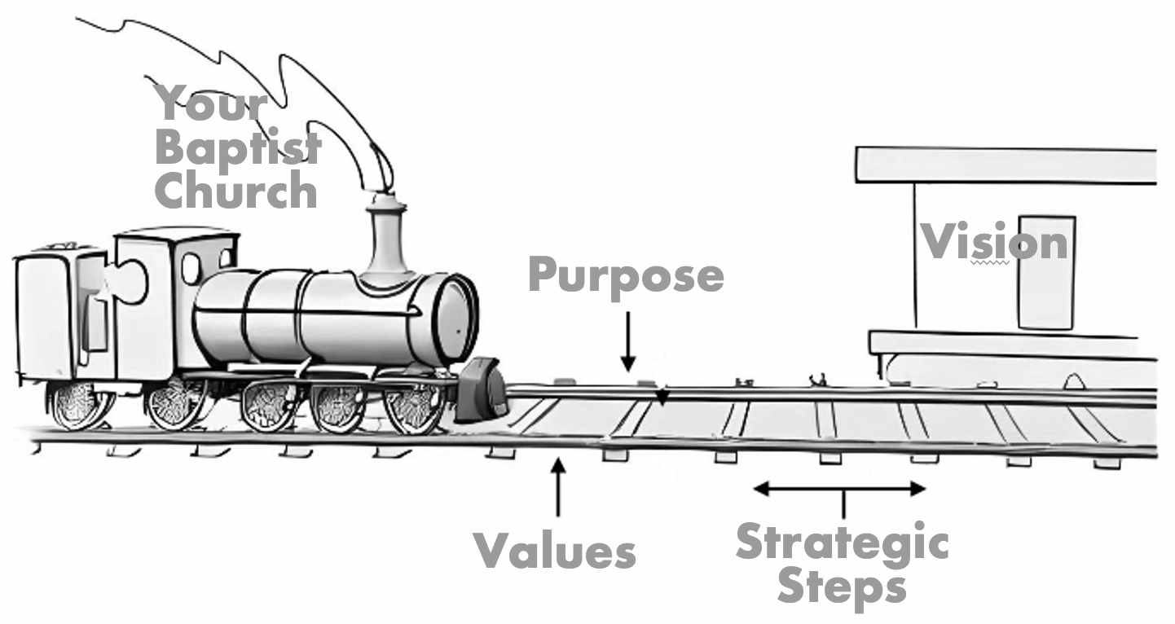

**Purpose:** Why we exist

**Values:** Motivate and shape the way we do things around here

**Vision:** Our future destination, a word picture of what we think the future might look like under God

**Principles**

**Purpose:** determined biblically

**Values:** uncovered not created

**Vision:** imparted by God, discovered through prayer, & acknowledged by the church body.

**Developing a Purpose Statement**

*Purpose is why we exist*

* Biblically Based
* Usually one sentence
* Over-arching rather than specific
* Can be applied to most churches
* Will never go out of date

“The purpose is part of the ministry’s congregational heart and soul. It is why the ministry exists...”

Malphurs, *Advanced Strategic Planning,* 105

**Developing a Values Statement**

*Values drive the way we do things around here*

* Values are uncovered not created!
* Are in the DNA of a church
* Are recognised by a “gut reaction” (emotive response)
* Build quite slowly & change very slowly

They may need to be changed if they are unbiblical. This will take time and involves a change in organizational culture.

“The constant, passionate, biblical core beliefs that drive the ministry.”

Malphurs *Advanced Strategic Planning* 83

For reflection: *“Values eat vision for breakfast.”*

**Developing a Vision Statement**

*Vision is our future destination, a word picture of what we think the future might look like under God*

* Vision is imparted by God, discovered through prayer, and acknowledged by the church Body
* Has a future aspect (doesn’t describe things presently)
* Has a specific nature (progress is measurable)
* Typically needs to be revisited or reviewed every 3 to 5 years

“A vision is a target that beckons.”

Bennis and Nanus, *Leaders: The strategies for Taking Charge*, 88.

**Developing a Strategic Plan**

*Strategic Goals: are the individual goals or steps we must take to reach our vision*

Each step should be SMART:

* **S**pecific
* **M**easurable
* **A**chievable
* **R**elated to reaching the vision
* **T**imed